Table of Contents

1 Introduction 1

1.1 Purpose 1

1.2 Scope 2

1.3 Definition and Acronyms 3

1.4 Overview 3

2 Overall Description 4

2.1 Product prospective 4

2.2 Product Function 5

2.3 Assumption and dependency 11

2.4 User Characteristics 11

2.5 Constrains 11

3 Specific requirement 11

3.1 External interface requirement 11

3.1.1 User interface 11

3.1.2 Software interface 17

3.1.3 Hardware interface 17

3.1.4 Communications Interfaces 17

3.2 Functional requirement 18

3.2.1 Login operation 18

3.2.2 Registration operation 18

3.2.3 Fee management 19

3.2.4 Attendance Management 19

3.2.5 Marks Management 20

3.3 Logical database connectivity 20

3.4 Performance requirement 22

3.5 Security 22

3.6 Maintainability 23

3.7 Diagram 23

3.7.1 ER Diagram 23

3.7.2 DFD 24

3.7.3 Use Case Diagram 25

3.8 References 26

# Introduction

The idea of developing “**Institute Management System**” project is come in my mind when I go to the Institute of computer education (LBSIT Institute) where we see that the data is handled manually in the form of files.

The “**Institute Management System**” has been developed to override the problems prevailing in practicing manual system. This software is supported to eliminate and in some cases, reduce the hardships faced by this existing system. Moreover, this system is designed for the particular need of the company to carry out operations in a smooth and effective manner.

The application is reduced as much as possible to avoid errors while entering the data. It is also provides error message while entering invalid data. No formal knowledge is needed for the users to use this system, as described above, can lead to error free, secure, reliable and fast management system. It can assist the user to concentrate on their other activities rather to concentrate on the record keeping. Thus, it will help organization in better utilization of resources.

## Purpose

The purpose of Online Institute Management is to automate the existing manual system to the help of computerized equipment and full-fledged computer software, fulfilling their requirements, so that their valuable data/information can be stored for a longer period with easy accessing and manipulation of the same. The required software and hardware are easily available and easy to work with Institute management System As described above, can lead to error, secure reliable and fast management system. It can assist the user to concentrate on their other activities rather to concentrate on the record keeping. Thus it will help organization in better utilization of resources. The organization can maintain computerized records without redundant entries. That means that one need not be distracted by information that is not relevant while being able to reach the information**.**

## Scope

The new system will automate the whole working of institute. In this project we will retrieve the information of student or update the information easily by the use of Computer. If any new student come into the institute for admission all the information regarding the student and in which course he / she wants to take admission or what the roll no given to the student all the information is stored into the database .we can easily retrieved , changed , updated or saved the information whenever we want.

The aim is to automate its existing manual system by the help of computerized equipment and full-fledged computer software, fulfilling their requirement, so that their valuable data/information can be stored for a longer period with easy accessing and manipulation of the same. Basically, the project describes how to manage for good performance and better services for clients.

Institute Management software is developed to cater the needs of the Education Sector. This Software helps Saving Time and Systemize the Running of Institute. It also reduces paper work & Manpower. It works on web based platform and highly user friendly ERP System. This website makes a bridge of communication between Students and Institute. Software uses the latest and advanced technology framework which makes it robust, secured, flexible, powerful and efficient to handle the complex processes and deliver the maximum performance. It is easily deployable, operatable and capable of integration with other systems and devices it can also be integrated with any Institute website or portal and is fully configurable to provide appropriate access to the wider Institute community including teachers, students and parents.

## Definition and Acronyms

The Institute management system has to handle records for much number of students and maintenance was difficult. Though it has used an information system, it was totally manual. Hence there is a need to upgrade the system with a computer based information system. This website provides the interface to resolve all over problems mentioned above.

|  |  |
| --- | --- |
| Designing Languages Used | HTML (Hyper Text Markup Language)  CSS(Cascading Style Sheet) |
| Programming Languages | JavaScript  JSP  Java |

## Overview

The objective is to design a system that can integrate all the above features in a single system, so that it can be easy to use .The new system should have all the records and files of the old system in a comprehensively linked manner so that whenever we want to retrieve some information, it can be done in an efficient manner. The system should be a one-step shop solution where all the different jobs regarding the various operations and functions in the centres can be done on a single window with least hassle. That is, the new system should be able to do work in the least amount of time and with much more efficiency and effectiveness than the existing system. The designing aspects of new system should be aimed towards basing all the data fields and data records in a single database, from where any operation on the data or data retrieval can be done easily. It should be designed in such a way that only the required information is displayed when asked for. Not like the manual system where one has to search in hard copy files to look for a particular record. It should remove, if not all majority of the problems that exists in the old system. Also it should be compatible, easy to understand and easy to modify. The aim would be to remove as many problems as possible from the existing system and design the new system in such a manner that it looks a very comprehensive approach to the stated objectives. The organization structure of the old system should be clearly understood so that the objectives it aims to achieve can be designed.

The main objectives of the new system are mentioned below:-

1. **Fast and Efficient:-** As compared to existing system, in new system the user can get the information fast, easily and efficiently from the software.
2. **Reliable and accurate: -** As in new system, the information is stored and processed in computers so that data will be more reliable and accurate.
3. **Centralized Data:-** In the existing system, data records are kept under file maintenance system due to this system the placement of the data is not at one particular place. But in new system, each and every record is maintained on computer, which leads to the centralization of data.
4. **Non Redundant Information: -** As in proposed system data is maintained on the computers so inconsistency does not occur which will never lead to problem like duplication of data.
5. **Easy to Access: -** As compared to existing system, in new system the users can easily and efficiently accesses the information from the computer.
6. **No Documentation: -** As everything is stored on the computer, so there is no need of documentation or maintaining the files.

# Overall Description

## Product prospective

The system mainly consists of Online Institute Management containing user interface and server side scripting. On user interface student and faculty can login and see the content and on server side all the data of the student and faculty are stored onto server to verify them. The scripting will be based on the categories like attendance view and daily activities. Further the institute management staff faculty can add/update/remove the resources when the time limit completed.

The system will also have an admin who has full-fledged rights with regards to managing resource. The user can view, submit online payment, uploading various information about their accounts etc. there are two types of user one is student and other is faculty member. Every user has different facility with a different username and having a password for private use. The two types of user differ from each other due to accessing limits to institute management system.

## Product Function

It shows the functions of the project that what can do this project and what cannot?

There are three different users who will be using this product:

* Institute Manager who will be acting as the administrator.
* Faculty members who are second level users accessing IMS (Institute management System).
* Student of the University who will be accessing the IMS online.

The features that are available to the Administrator are:

* The administrator has the full-fledged rights over the IMS.
* Can create/delete an account.
* Can view the accounts or users.
* Can change the password.
* Can hide any kind of features for the both of users.
* Insert/delete/edit the information of available on IMS.
* Can access all the accounts of the faculty members/students.

Administrator can login with their provided username and password and able to create/update/delete faculty account. If the username or password does not match then the instructor will return back to login page again. If the username and password is verified then the admin is able to hide feature, create faculty, view student detail etc.

The features available to the Faculty members are:

* Can add/update new Student.
* Can update the attendance of students online.
* Can upload quiz for the test.
* Can upload marks, assignments, reading materials for student.
* Can view the student list.
* Can view student fee detail.

Instructor can login with their provided username and password and able to update course, marks, attendance detail and topics. If the username or password does not match then the instructor will return back to login page again. If the username and password is verified then the instructor shall be able to create account for new student.

This system allows instructor to modify and update quiz online for student. For updating the quiz it is necessary to login with their username and password.

The features available to the Students are:

* Can view their marks.
* Can view the various reading material.
* Can view attendance.
* Can view and modify its profile but can modify it to some limited range.
* Can pay their fee online.

Student can login with their provided username and password and able to view and access all information regarding to the account. If the username and password does not match then the user will return back to login page again and they will read only some content of this website.

This system allows student to access their marks online pay fee online. When the student course is end then s/he can able to give online quiz exam and after some time his /her mark is updated to his/her profile and s/he will be able to see their marks but they not able to modify them.

Functionality performed by Admin Account

|  |  |
| --- | --- |
| Function for admin | |
| Manage faculty | Adding New faculty  Edit the Exiting faculty  View Profile of the Student and faculty  Listing of all Student |
| Manage Fees | Edit Fees for Student  View Details of the Fees  Listing of all Fees  Filters Fees according to Student |
| Manage Attendance | View Attendance of Student  Edit Attendance of Student  Listing of the Attendance  Filter attendance according to Student |

Functionality performed by Teacher Account

|  |  |
| --- | --- |
| Function for Teacher | |
| Manage Student | Add new student  View Profile of the Student  Listing of all Student |
| Manage Fees | View Details of the Fees  Listing of all Fees |
| Manage Attendance | Add Attendance of Student  Edit Attendance of Student  Listing of the Attendance  Filter attendance according to Student |

Functionality performed by Student Account

* Login for Student
* View his Registration Details
* Edit Profile for Student
* View his Fess Payment History
* View his Attendance History
* View his marks and grade

Static Pages and other sections:

* These static pages will be available in project
* Home Page with good UI (user interface) Home
* Page will contain an animated slider for images banner
* About us page will be available which will describe about the project
* Contact us page will be available in the project

Functionalities provided by Institute Management System

* Institute Management System also manage the Registration Details of Student,
* Teacher Details, Attendance, Fee Management and Time Table etc.
* It tracks all the information of Student, Registration, and Teachers etc.
* Manage the information of Students and Teachers.
* Shows the Time Table, Attendance of Class, Fee Details, Student information.
* Editing, adding and updating of Records of improved which result in proper resource management of Institute Data.

## Assumption and dependency

* Exam centers are already created and information’s available for use.
* Roles and responsibilities are already established.
* Administrator is already created.

## User Characteristics

Users of Online School Management

There are three types of users available in the project .

* Admin : with full access ,
* Teacher: with limited access
* Student : with limited access

## Constrains

* GUI is only in plain English.
* Login and password is used for identification of authorized persons.
* Examination city entered should be perfect.
* No checks of time line are being implemented.

# Specific requirement

This section provides all the detailed functional and non-functional requirements.

## External interface requirement

### User interface

**Welcome page:**

It shows the welcome page to all users.

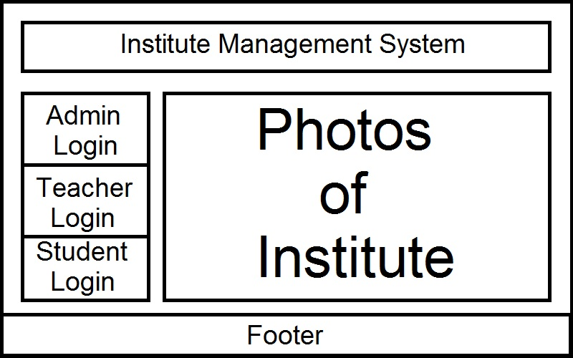

**Admin login:**

Here admin can login and use some feature as below.

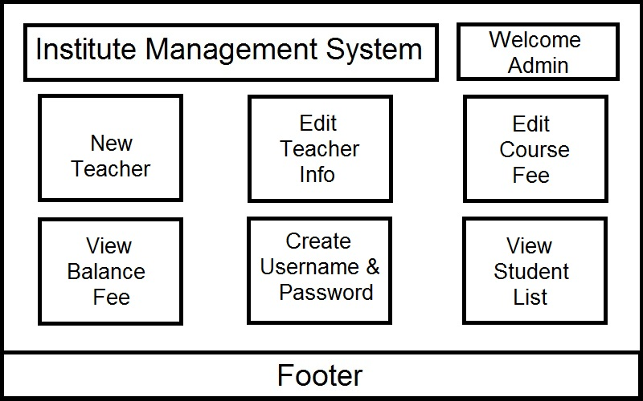

**New teacher appointment**

Admin can create a new teacher as per requirement.

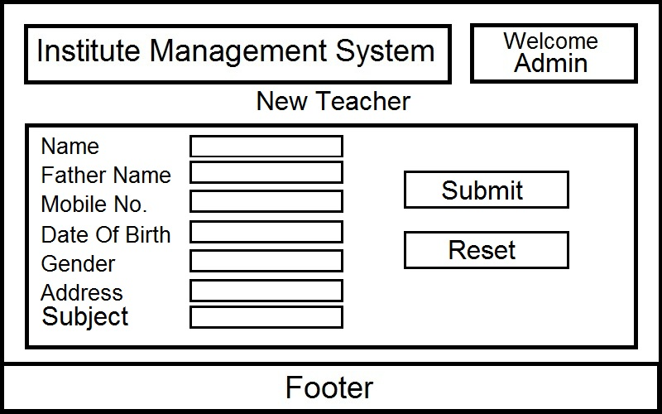

**Faculty login:**

Faculty can login to add student records, update student record, update student fee and update marks of student.

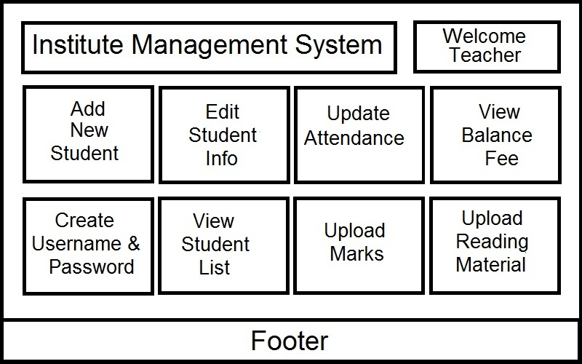  
**Student login:**

Here student can login to read all content and use some feature of the website.

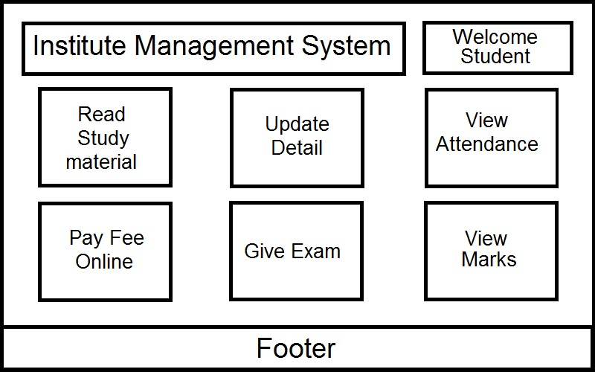

**Admission of student:**

Here all detail of a new student is filled by faculty.

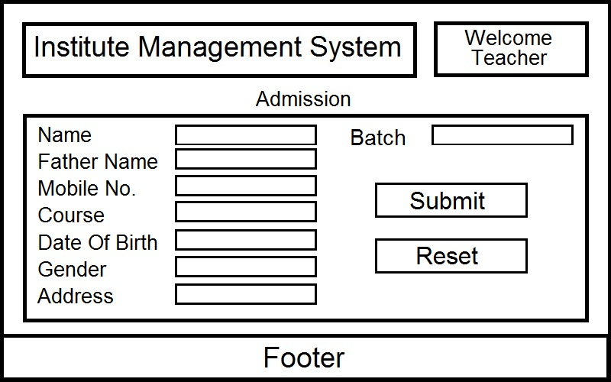

**Update fee:**

Here fee of the student is updated by student online.

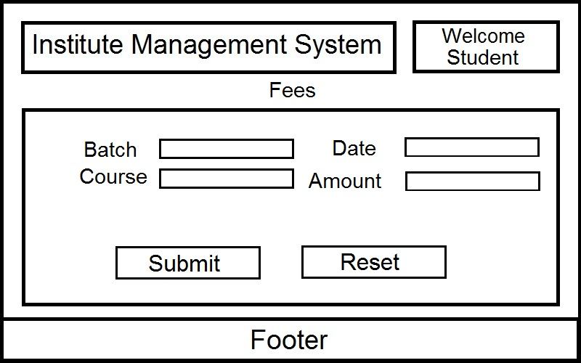

**See fees balance:**

This area shows the balance of fee of student. It is shown on faculty and student both page.

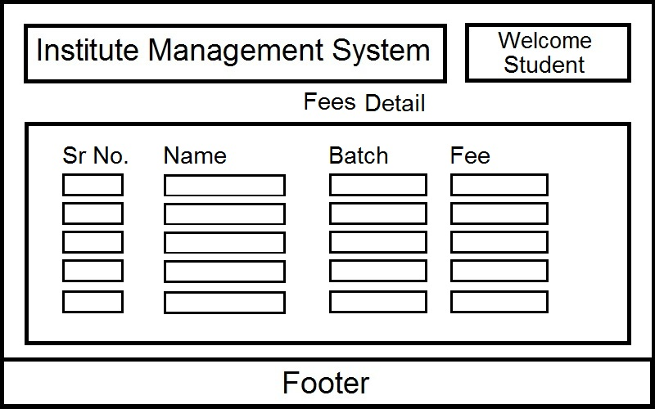

**Update attendance**

Here the attendance is updated by the faculty online.

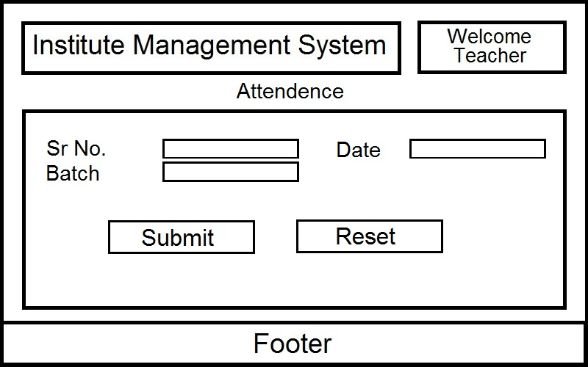

**View attendance**

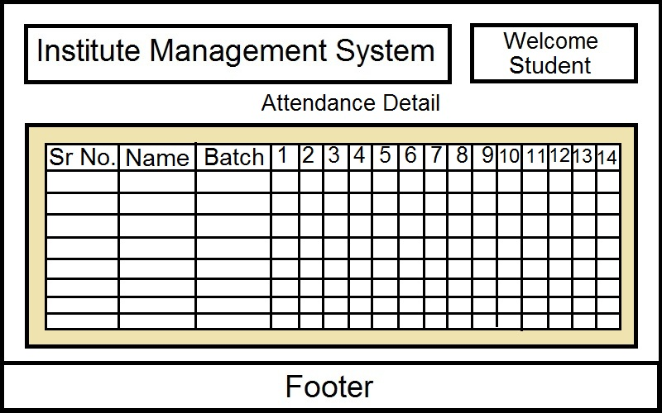

### Software interface

This area is explained about the software requirement for the website.

|  |  |  |
| --- | --- | --- |
| **Software used** | **Software name** | **Description** |
| Operating system | Window, Mac, android etc. (any one) | We have chosen **Windows operating system** for its best support and user-friendliness. |
| Database | DB2, MySQL, Oracle, SQLite, SQL Server, etc. (any one) | To save the student records, faculty records we have chosen **MySQL** database. |
| Programming language | VB.Net, JSP, PHP, Python, (any one) | To implement the project we have chosen **JSP** language for its more interactive support. |
| **I am using NetBeans IDE for writing this project and creating connectivity to database.** | | |

### Hardware interface

**Client side**

* Operating system: window 7/8/10
* Processor: Pentium 1.5 GHz or higher.
* Ram: 1GB and above
* Hard drive: 3GB or more

**Server Side**

* Operating system: window 7/8/10
* Processor: Pentium 2.4 GHz or higher.
* Ram: 2GB and above
* Hard drive: 10GB or more

### Communications Interfaces

The Customer must connect to the internet to access the website.

* Dial up modem 128kb.
* Broadband network

## Functional requirement

This section provides detail of all major functionalities supported by Institute Management System.

### Login operation

|  |  |
| --- | --- |
| **Functional Requirement Id** | **FR 1** |
| **Requirement Title** | Login Operation |
| **Requirement Description** | * Registered user enters username and password. * User clicks on required ‘Login’ button. * System should authenticate and create a valid user session upon successful authentication and redirect user Welcome Page. |
| **Business Rationale** | * Allow Registered user to get their welcome page according to their type of user (Admin, Teacher and Student ) |
| **Exception Scenarios** | * If authentication fails, user should be redirected to login page showing “User id or password incorrect” message. |
| **Dependencies** | * User must be registered on Database. |

### Registration operation

|  |  |
| --- | --- |
| **Functional Requirement Id** | **FR 2** |
| **Requirement Title** | Registration and Admission |
| **Requirement Description** | * faculty should fill a form * Faculty enters the New Admission Student Information Student Name, Gender, Data of Birth, Mobile No., Father’s Name, Address, * User clicks on “Submit” button. * Post Successfully Admitted |
| **Business Rationale** | * Allow Faculty User to save the newly admitted student’s information into database. |
| **Exception Scenarios** | * Two student’s admission no. must not same. |
| **Dependencies** | * User must be a Faculty. * FR1 User should be logged in. |

### Fee management

|  |  |
| --- | --- |
| **Functional Requirement Id** | **FR 3** |
| **Requirement Title** | Fee Management |
| **Requirement Description** | * Teacher is being allowed to display any Student’s fee. * User enters Enrollment No., Student Name and DOB and click on Fee Detail. * Teacher will see the fee detail of student. * S/he needs to click on fee detail of student. |
| **Business Rationale** | * Allow User to get Students’ fee details. |
| **Dependencies** | * User should be a Teacher or student or admin. * FR1 User should be logged in. |

### Attendance Management

|  |  |
| --- | --- |
| **Functional Requirement Id** | **FR 4** |
| **Requirement Title** | Attendance |
| **Requirement Description** | * The Attendance Function should display all Students Attendance by Day, Month and Year. * Teacher can take Batch wise attendance daily. * Teacher have a daily form in which all student name class present and have two option first present and second is absent they must select one and the data will save in database. |
| **Business Rationale** | * Allow Teacher User to easily update, edit and display daily attendance of students |
| **Exception Scenarios** | * Internal Error of database |
| **Dependencies** | * User should be a Teacher. * FR1 User should be logged in. |

### Marks Management

|  |  |
| --- | --- |
| **Functional Requirement Id** | **FR 4** |
| **Requirement Title** | Marks management |
| **Requirement Description** | * Student should be logged in. * Student should be entering enrollment no. name and date of birth. * Click on “Marks” * Teacher should be login. * Enter enrollment No. and marks. * Click on “Submit.” |
| **Business Rationale** | * Allow Faculty User to update the newly admitted student’s Marks into database. |
| **Exception Scenarios** | * Before seeing marks it is compulsory to give quiz. |
| **Dependencies** | * User must be a Faculty or student. * FR4 User should be logged in. |

## Logical database connectivity

|  |  |  |  |
| --- | --- | --- | --- |
| Student | | | |
| Field name | Field type | Field size | Key attribute |
| Student_Id | INT | -- | Primary |
| Password | Varchar2 | 10 | Hidden |
| Name | Varchar2 | 25 |  |
| Father_Name | Varchar2 | 25 |  |
| Date_of_Birth | Date | -- |  |
| Gender | Varchar2 | 7 |  |
| Mobile_No | Varchar2 | 10 |  |
| Email_Id | Varchar2 | 40 |  |
| Date_of_joining | Date | -- |  |
| Address | Varchar2 | 50 |  |
| State | Varchar2 | 15 |  |
| District | Varchar2 | 15 |  |
| Pincode | INT | -- |  |

|  |  |  |  |
| --- | --- | --- | --- |
| Teacher | | | |
| Field Name | Field type | Field size | Key attribute |
| Teacher_Id | INT | -- | Primary |
| Password | Varchar2 | 10 | Hidden |
| Name | Varchar2 | 25 |  |
| Father_Name | Varchar2 | 25 |  |
| Date_of_Birth | Date | -- |  |
| Gender | Varchar2 | 7 |  |
| Mobile_No | Varchar2 | 10 |  |
| Email_Id | Varchar2 | 40 |  |
| Address | Varchar2 | 50 |  |
| State | Varchar2 | 15 |  |
| District | Varchar2 | 15 |  |
| Pincode | INT | -- |  |

|  |  |  |  |
| --- | --- | --- | --- |
| Exam | | | |
| Field Name | Field type | Field size | Key attribute |
| Exam_Id | INT | - | Primary |
| Student_Id | INT | -- | Foreign |
| Date | Date | -- |  |
| Course_Id | INT | -- | Foreign |

|  |  |  |  |
| --- | --- | --- | --- |
| Exam Result | | | |
| Field Name | Field type | Field size | Key attribute |
| Exam_Id | INT | -- | Foreign |
| Student_Id | INT | -- | Foreign |
| Course_Id | INT | -- | Foreign |
| Marks | INT | -- |  |

|  |  |  |  |
| --- | --- | --- | --- |
| Course | | | |
| Field Name | Field type | Field size | Key attribute |
| Course_Id | INT | -- | Primary |
| Course_Name | Varchar2 | 30 |  |
| Duration | INT | -- |  |
| Fee | INT | -- |  |
| Teacher_Id | INT | -- | Foreign |
| Batch | Time | -- |  |

|  |  |  |  |
| --- | --- | --- | --- |
| Attendance | | | |
| Field Name | Field type | Field size | Key attribute |
| Date | Date | -- |  |
| Student_Id | INT | -- | Foreign |
| Status | Varchar2 | 2 |  |

|  |  |  |  |
| --- | --- | --- | --- |
| Fee Detail | | | |
| Field name | Field type | Field size | Key attribute |
| Student_Id | INT | -- | Foreign |
| Course_Id | INT | -- | Foreign |
| Fee | INT | -- |  |
| Submited | INT | -- |  |
| Balance | INT | -- |  |

|  |  |  |  |
| --- | --- | --- | --- |
| Admin | | | |
| Field name | Field type | Filed size | Key attribute |
| Username | INT | -- | Unique |
| Password | Varchar2 | 10 | Hidden |
| Name | Varchar2 | 25 |  |

## Performance requirement

The following are the key performance requirements.

* All pages load within 3 to 4 seconds throughout the US region.
* Search result should be displayed within 2 to 3 second.

Software system attributes requirements

## Security

1. Login operation should be performed using transport layer security.
2. All password information should be encrypted using #tag.
3. Registration process should use CAPTCHA to prevent machine/ robot brute force attacks.
4. All input filled should be validated for JavaScript.

## Maintainability

The following maintainability feature should be supported.

* All code artefacts should have proper documentation.
* All code components should be thoroughly tested and the test coverage should be more than 85%.

## Diagram

### ER Diagram

### DFD

**First level DFD**

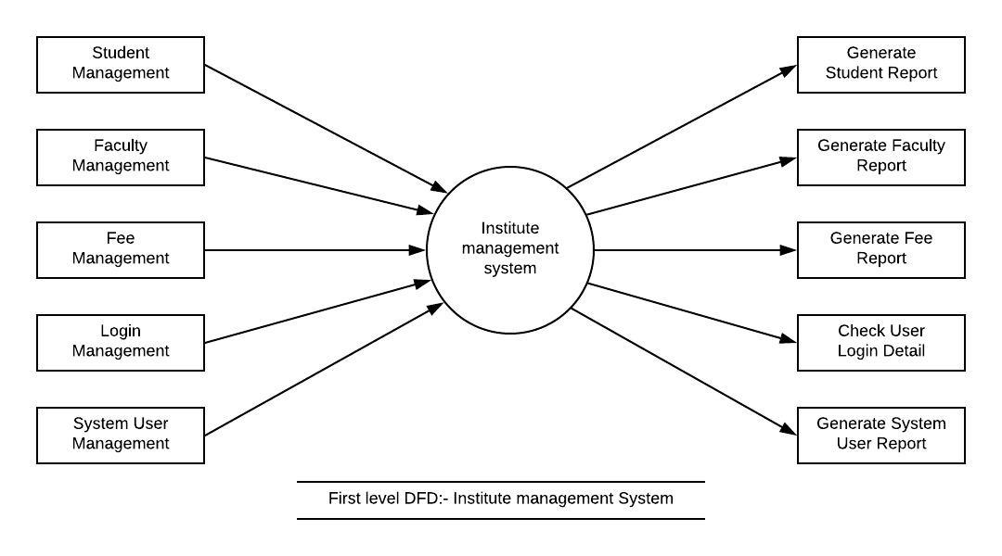

**Second Level DFD**

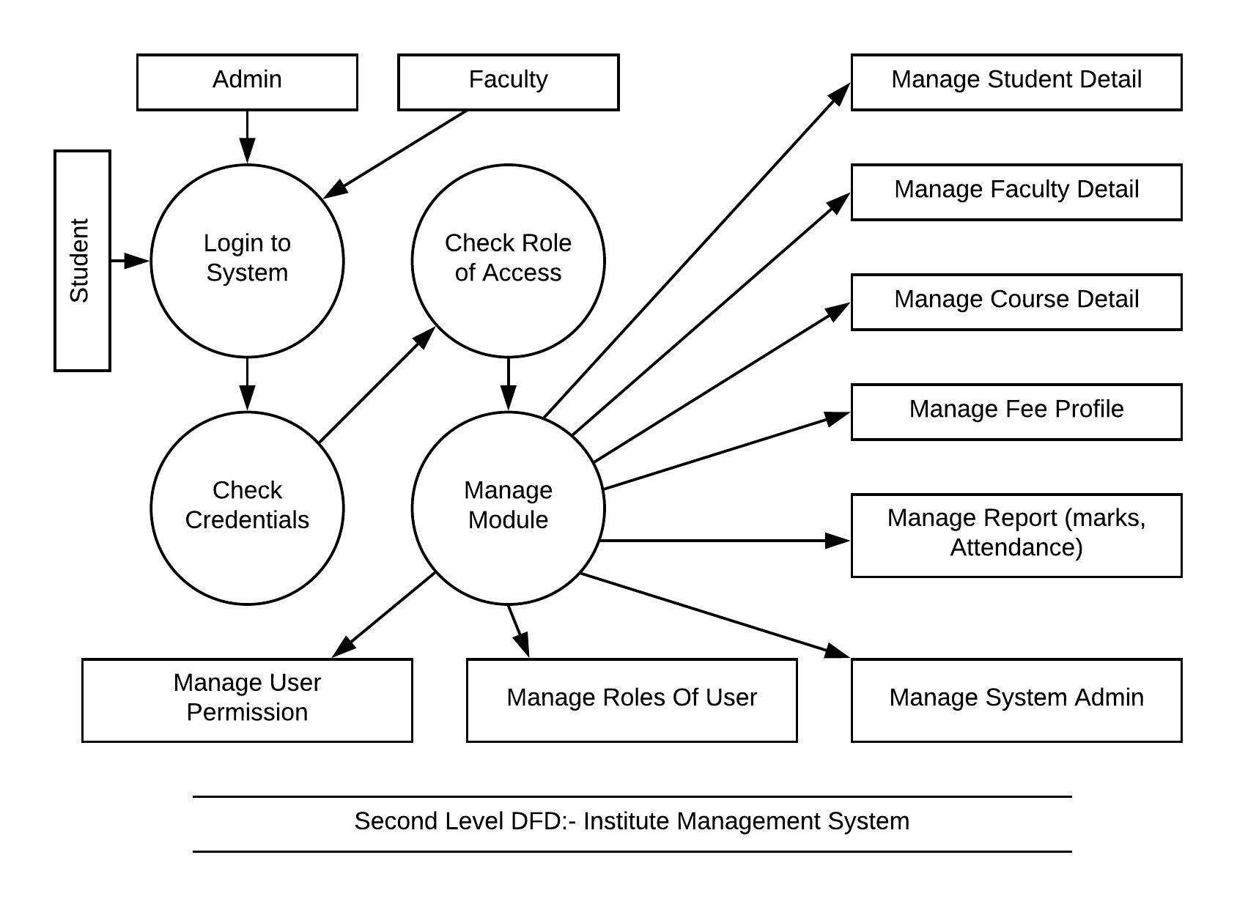

### Use Case Diagram

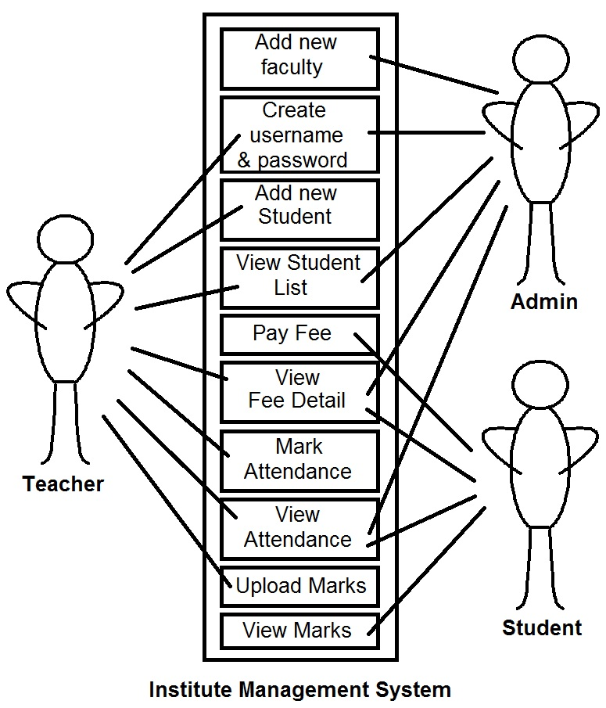

## References

<https://www.w3schools.com/>

<https://www.javatpoint.com/>

<https://netbeans.org/tutorials/>

<https://krazytech.com/>

<http://shodhganga.inflibnet.ac.in/>

<https://www.youtube.com/>

<https://www.slideshare.net/>

<https://www.scribd.com/>